

Course Project Report
Subject: SWD392

– Da Nang, July 2026 –
Table of Contents
Record of Changes 3
I. Overview 4
I.1 Project Information 4
I.2 Project Team 4
II. Requirement Specification 4
II.1 Problem description 4
II.2 Major Features 4
II.3 Context Diagram 4
II.4 Nonfunction Requirements 5
II.5 Functional requirements 5
II.5.1 Actors 5
II.5.2 Use Cases 5
II.5.2 .1 Diagram(s) 5
II.5.2.2 Use case descriptions 6
II.5.3 Activity diagram 8
III. Analysis models. 9
III.1 Interaction diagrams 9
III.2 State diagram 10
IV. Design specification 11
IV.1 Integrated Communication Diagrams 11
IV.2 System High-Level Design 11
IV.3 Component and Package Diagram 11
IV.4 Class diagram 12
IV.5 Database Design 12
V. Implementation 13
V.1 Map architecture to the structure of the project 13
V.2 Map Class Diagram and Interaction Diagram to Code 13
V. Applying Alternative Architecture Patterns 13
V.1 Applying the service-oriented architecture 13
V.2 Applying Service Discovery Pattern in the service-oriented architecture 13

Record of Changes
Date | A*  M, D | In charge | Change Description
*A - Added M - Modified D - Deleted

I. Overview

I.1 Project Information
- Project name: ProjectFlow — Project Management System
- Project code: PF
- Group name: SWD392-G4
- Software type: Web Application

I.2 Project Team
Full Name | Role | Email | Mobile
Nguyen Phuong Tam | Lecturer | TamNP4@fe.edu.vn
Nguyen Chi Vuong | Leader | nguyenchivuong.73@gmail.com | 0778579293
Nguyen Dac Thinh | Member
Le Duc Son | Member
Ho Trung Hieu | Member
Cao Nguyen Dang Khoa | Member

II. Requirement Specification

II.1 Problem description
Modern software development teams frequently struggle with fragmented communication tools and siloed task management. Developers, project managers, and stakeholders often rely on a patchwork of spreadsheets, chat tools, and email threads to coordinate work — leading to lost context, missed deadlines, and unclear accountability.
ProjectFlow is a new software system that provides a single, unified, browser-based platform where:
- Teams can be organized into named Workspaces, each with its own members, roles, projects, and activity history.
- Projects within a workspace are tracked with status (ACTIVE, PLANNING, COMPLETED, ON_HOLD, CANCELLED), priority (LOW, MEDIUM, HIGH, CRITICAL), start dates, and due dates.
- Tasks within a project move through a defined lifecycle (TODO → IN_PROGRESS → REVIEW → DONE) and can be assigned to individual members via a Kanban board with drag-and-drop.
- Real-time collaboration is supported: when a task is updated or a member is assigned, all workspace members receive a live Socket.IO event that updates the UI without a page refresh.
- Notifications alert users when they are assigned to a task or when a new team member is added.
- Activity logs provide a chronological audit trail of all workspace events (project creation, task completion, member additions).
- Dashboard statistics give project managers an at-a-glance view of project health: total projects, active projects, task completion rate, overdue tasks, and a Kanban breakdown by status.

II.2 Major Features
FE-01: User Authentication: Register, login, and logout with credential-based auth. JWT sessions (30 days), bcrypt password hashing (salt=10), token-version invalidation for force-logout. Rate limiting: 10 login attempts/minute/IP+email.
FE-02: Workspace Management: Create multiple workspaces, switch between them via a cookie-persisted workspaceId. Each workspace is an isolated organizational unit with its own members, projects, and activity log.
FE-03: Team Management: Invite registered users to a workspace by email. Three roles: OWNER, ADMIN, MEMBER. OWNER/ADMIN can invite and remove members.
FE-04: Project Management: Create, edit, delete projects within a workspace. Projects have name, description, status, priority, start date, and due date with cross-field validation (dueDate ≥ startDate).
FE-05: Task Management: Create, edit, delete tasks within a project. Tasks have title, description, status (Kanban columns), priority, assignee, creator, and due date.
FE-06: Kanban Board: Visualize tasks organized into status columns (To Do, In Progress, Review, Done). Drag-and-drop task cards between columns using dnd-kit.
FE-07: Real-Time Collaboration: After each mutation (task update, project update, assignment), the API broadcasts a Socket.IO event to all workspace clients. UI updates without page refresh via TanStack Query cache invalidation.
FE-08: In-App Notifications: Notification bell with unread badge count. Notifications are created on task assignment. Users can mark notifications as read individually or all at once.
FE-09: Activity Feed: Chronological workspace activity log: who created/updated/deleted which entity and when.
FE-10: Dashboard & Analytics: Stats panel: total/active/completed projects, task completion metrics, overdue task count, tasks-by-status pie chart (Recharts), recent projects list, personal task list.
FE-11: Calendar View: Monthly calendar showing tasks by due date for the active workspace.
FE-12: Global Search: Full-text search across projects and tasks in the active workspace with a command-palette shortcut (Cmd+K).
FE-13: Theme Support: Dark/light mode toggle with system preference detection via next-themes.

II.3 Context Diagram
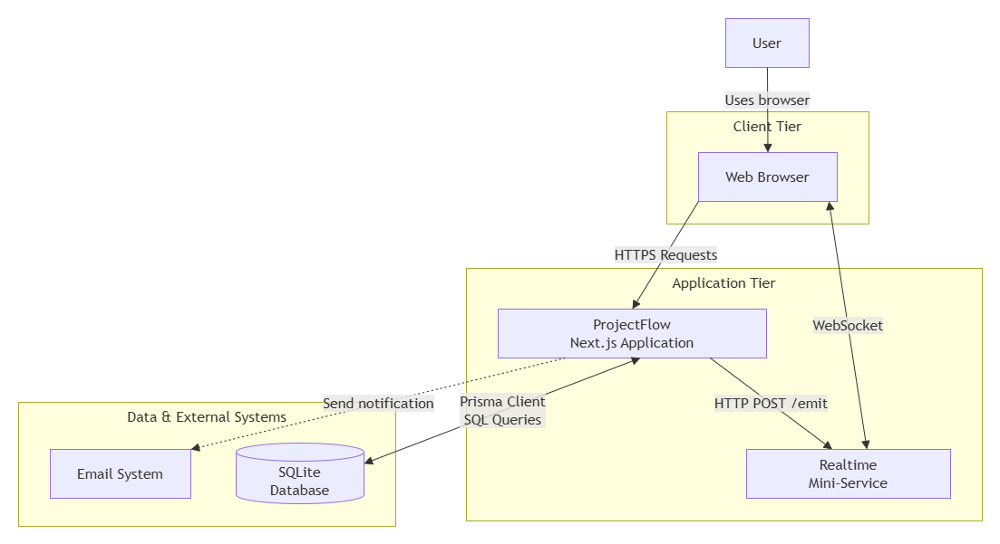
Figure 2.1: Context Diagram

II.4 Nonfunctional requirements
[Provide the descriptions for the functions which have no UI (or not screens), i.e batch/cron job, service, API, etc.]
# | Feature | System Function | Description
1 | Security | Password Hashing | All user passwords are hashed with bcryptjs (salt rounds = 10) before storage. Plain-text passwords are never stored or logged. Applied at POST /api/register and when changing passwords.
2 | Security | JWT Session Management | Sessions use JWT tokens stored in HTTP-only cookies. Tokens expire after 30 days. The tokenVersion field in the DB is checked every 5 minutes to support forced logout on password change (token invalidation without requiring logout).
3 | Security | Role-Based Access Control | Server-side RBAC enforced on every API route. Only OWNER/ADMIN may delete projects or invite/remove members. Task edits are restricted to the task's creator, assignee, or a workspace admin. All checks are done in getApiContext() before business logic runs.
4 | Security | Rate Limiting | The login endpoint is limited to 10 attempts per minute per IP + email combination, using an in-memory sliding-window counter in src/lib/rate-limit.ts. Returns error on excess.
5 | Security | Safe API Responses | The passwordHash field is never included in any API response. All user-related queries explicitly enumerate safe fields (id, name, email, image) using Prisma select.
6 | Performance | Aggregate Dashboard Queries | Dashboard stats use Prisma groupBy aggregation rather than loading all records into memory, ensuring O(1) DB round-trips for totals at GET /api/stats.
7 | Performance | Client-Side Caching | TanStack Query (React Query) provides configurable staleTime caching. Dashboard stats are cached for 30 seconds; user profile for 5 minutes. Reduces redundant API calls and unnecessary re-renders.
8 | Reliability | Realtime Best-Effort Delivery | Failures to emit Socket.IO events are caught with try/catch and logged via console.warn but never break the main API request. The realtime broadcast is treated as a non-critical enhancement.
9 | Reliability | Atomic Database Transactions | Multi-step DB mutations (e.g., create project + log activity, create task + log activity) are wrapped in Prisma $transaction() to ensure all-or-nothing atomicity.
10 | Usability | Responsive UI | Mobile-first TailwindCSS v4 grid layouts. Skeleton loaders for all async data. Dark/light theme support with system preference detection.
11 | Scalability | Decoupled Realtime Service | The Socket.IO mini-service runs on a separate port (3003) and can be deployed/scaled independently from the Next.js application.
12 | Scalability | ORM Abstraction | Prisma ORM abstracts the database layer. Switching from SQLite to PostgreSQL or MySQL requires only a one-line datasource config change in prisma/schema.prisma.
13 | Testability | Unit Tests | Unit tests are written with Vitest and @testing-library/react. Test coverage includes constants validation, rate-limit logic, and utility functions.
14 | Maintainability | Centralized Constants | Domain constants (statuses, priorities, roles, badge CSS classes, labels) are centralized in src/lib/constants.ts. Validation schemas use Zod for runtime type safety on all API routes.

II.5 Functional requirements

II.5.1 Actors
# | Actor | Description
1 | Guest | An unauthenticated visitor. Can only access /login and /register pages. Cannot access any protected resource.
2 | Authenticated User | A registered user who is logged in. Can create and join workspaces, manage their profile.
3 | Workspace Member | A logged-in user who belongs to the active workspace with the MEMBER role. Can view and create projects, create tasks, and edit tasks they own or are assigned to.
4 | Workspace Admin | A workspace member with the ADMIN role. Can invite/remove members, delete projects, and edit tasks of other members. Inherits all Member actions.
5 | Workspace Owner | The creator of a workspace with the OWNER role. Has all Admin privileges plus workspace deletion. Inherits all Admin actions.
6 | Realtime Mini-Service | The Socket.IO server (port 3003). Receives HTTP POST /emit calls from the Next.js API and broadcasts events to all connected clients in the workspace room. Secondary/system actor.
7 | Prisma Database | The SQLite database accessed via Prisma ORM. Secondary/system actor that stores all persistent application data.

II.5.2 Use Cases

II.5.2 .1 Diagram(s)
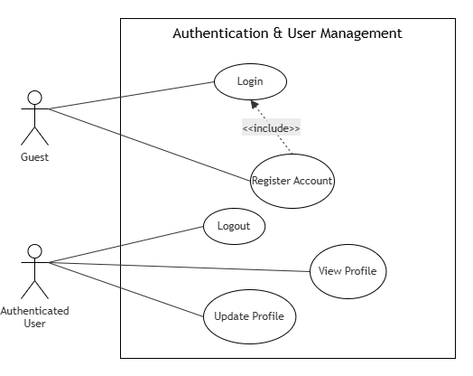
Figure 2.3: Authentication & User Management

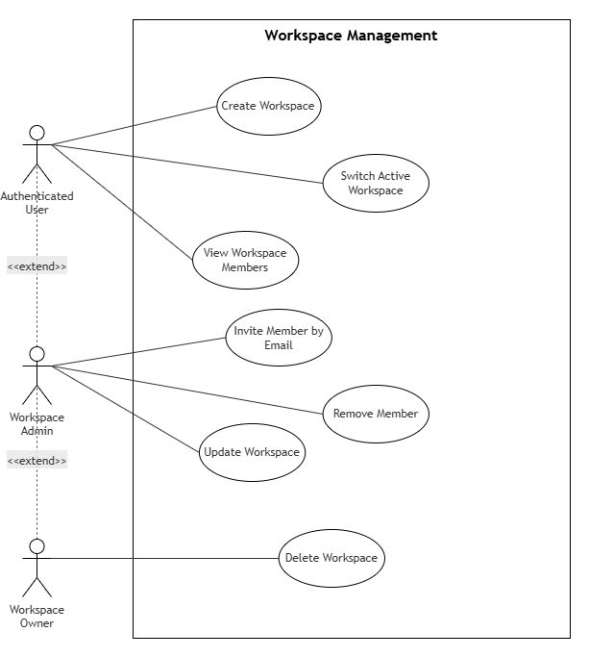
Figure 2.4: Workspace Management

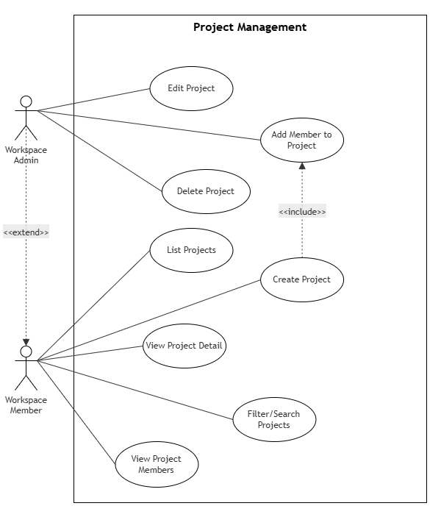
Figure 2.5: Project Management
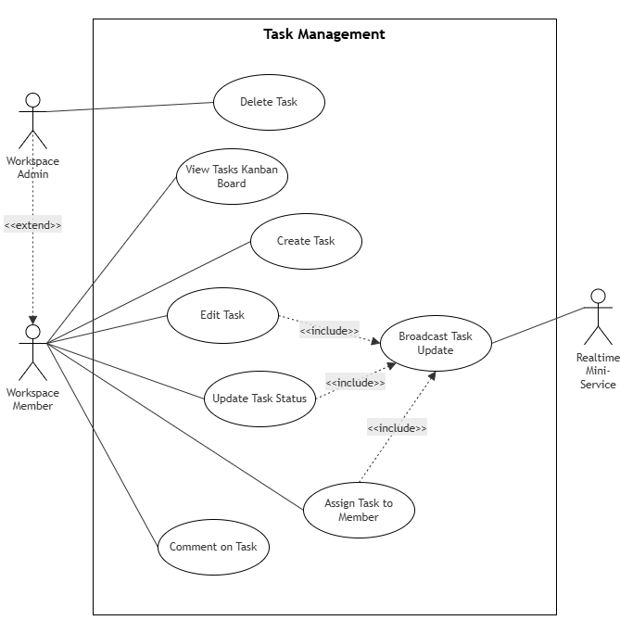
Figure 2.6: Task Management

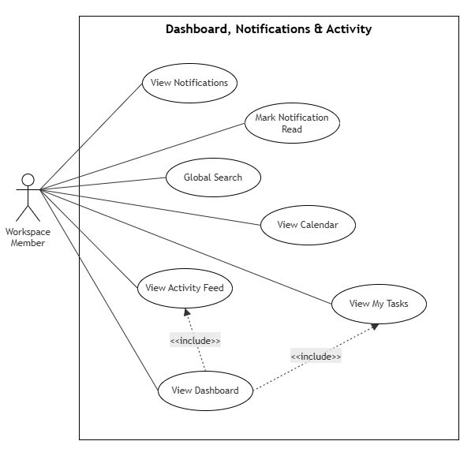
Figure 2.7: Dashboard, Notifications & Activity

II.5.2.2 Use case descriptions
ID | Use Case | Actors | Use Case Description
UC-01 | Register Account | Guest | Create a new user account; auto-creates personal workspace
UC-02 | Login | Guest | Authenticate with email/password, establish JWT session
UC-03 | Logout | Authenticated User | Terminate the current session
UC-04 | View Profile | Authenticated User | View current user name, email, avatar
UC-05 | Update Profile | Authenticated User | Update name or avatar image
UC-06 | Create Workspace | Authenticated User | Create a new isolated workspace
UC-07 | Switch Active Workspace | Authenticated User | Change the active workspace context via cookie
UC-08 | View Workspace Members | Workspace Member | List all members and their roles
UC-09 | Invite Member to Workspace | Workspace Admin | Add a registered user to workspace by email
UC-10 | Remove Member from Workspace | Workspace Admin | Remove a user from the workspace
UC-11 | Update Workspace | Workspace Admin | Rename the workspace
UC-12 | Delete Workspace | Workspace Owner | Permanently delete the workspace and all its data
UC-13 | List Projects | Workspace Member | View all projects in the workspace
UC-14 | Create Project | Workspace Member | Create a new project with metadata and initial members
UC-15 | View Project Detail | Workspace Member | View project details, member list, and Kanban task board
UC-16 | Edit Project | Workspace Admin | Update project metadata (name, status, priority, dates)
UC-17 | Delete Project | Workspace Admin | Permanently delete a project and all its tasks
UC-18 | Filter/Search Projects | Workspace Member | Filter projects by status, priority, or keyword
UC-19 | View Project Members | Workspace Member | List all members of a specific project
UC-20 | Add Member to Project | Workspace Admin | Add a workspace member to a project
UC-21 | View Tasks (Kanban) | Workspace Member | View all tasks in Kanban column layout
UC-22 | Create Task | Project Member | Create a task within a project
UC-23 | Edit Task | Creator / Assignee / Admin | Update task metadata (title, description, priority, due date)
UC-24 | Update Task Status | Creator / Assignee / Admin | Move task between Kanban columns (status change)
UC-25 | Assign Task to Member | Creator / Admin | Assign or reassign a task to a project member
UC-26 | Delete Task | Creator / Admin | Permanently delete a task
UC-27 | Comment on Task | Project Member | Add a text comment to a task
UC-28 | Broadcast Task Update | Realtime Mini-Service | Push real-time event to all workspace clients
UC-29 | View Dashboard | Workspace Member | View aggregated workspace statistics and analytics
UC-30 | View My Tasks | Workspace Member | View tasks assigned to the current user
UC-31 | View Activity Feed | Workspace Member | View chronological workspace activity log
UC-32 | View Notifications | Workspace Member | View in-app notifications
UC-33 | Mark Notification Read | Workspace Member | Mark one or all notifications as read
UC-34 | Global Search | Workspace Member | Search projects and tasks by keyword
UC-35 | View Calendar | Workspace Member | View tasks by due date on a monthly calendar

UC-01: Register Account
UC ID and Name: | UC-01 — Register Account
Created By: | Nguyen Chi Vuong | Date Created:
Primary Actor: | Guest | Secondary Actors: | Prisma Database
Trigger: | Guest navigates to /register and submits the registration form with name, email, and password
Description: | Allows an unauthenticated visitor to create a new user account. Upon success, the system automatically creates a personal workspace for the new user and establishes a JWT session.
Preconditions: | PRE-1: The user is not authenticated. PRE-2: The user has a valid email address not already registered in the system.
Postconditions: | POST-1: A new User record is created with hashed password. POST-2: A personal Workspace is created. POST-3: User is added as workspace OWNER. POST-4: JWT session is established. POST-5: User is redirected to the dashboard (/).
Normal Flow: | 1.0 Guest opens /register. 1.1 System renders the registration form (Name, Email, Password). 1.2 Guest fills in all fields and clicks Submit. 1.3 System validates with Zod: name ≥ 2 chars, valid email format, password ≥ 8 chars. 1.4 System checks email is not already registered. 1.5 System hashes the password with bcryptjs (salt=10). 1.6 System runs $transaction: creates User, Workspace, WorkspaceMember (OWNER), starter Task. 1.7 System calls NextAuth to create a JWT session. 1.8 System redirects user to /.
Alternative Flows: | 1.4.A Email already in use → HTTP 409 "Email is already in use." 1.3.A Zod validation fails → HTTP 400 with first error message.
Exceptions: | 1.6.E1 Database transaction failure → all partial writes rolled back; HTTP 500 returned.
Priority: | High — Must Have
Frequency of Use: | Low (once per user lifetime)
Business Rules: | BR-01, BR-02, BR-03
Other Information: | If the $transaction fails mid-way, all partial writes (User, Workspace, WorkspaceMember) are rolled back atomically via Prisma.
Assumptions: | The user has a valid email address and access to a modern web browser.

UC-02: Login
UC ID and Name: | UC-02 — Login
Created By: | Nguyen Chi Vuong | Date Created:
Primary Actor: | Guest | Secondary Actors: | Prisma Database, RateLimitService
Trigger: | Guest navigates to /login and submits email + password credentials
Description: | Authenticates an existing user by verifying their email and password, then establishes a 30-day JWT session and redirects to the dashboard.
Preconditions: | PRE-1: User has a registered account. PRE-2: User is not already authenticated. PRE-3: Rate limit for this IP+email has not been exceeded.
Postconditions: | POST-1: JWT session cookie set (maxAge = 30 days). POST-2: lastVersionCheck timestamp initialized in the JWT. POST-3: User redirected to /.
Normal Flow: | 2.0 Guest opens /login. 2.1 System renders login form (Email, Password). 2.2 Guest enters credentials and clicks Login. 2.3 System normalizes email (trim, lowercase). 2.4 System checks rate limiter: ≥ 10 attempts in last 60s → reject. 2.5 System queries DB for User by email. 2.6 System compares password with stored bcrypt hash via bcrypt.compare(). 2.7 System creates JWT: { id, name, email, image, tokenVersion }. 2.8 Session cookie set; user redirected to /.
Alternative Flows: | 2.4.A Rate limit exceeded → "Too many attempts. Please try again in 1 minute." 2.5.A Email not found → "Incorrect email or password." 2.6.A Password mismatch → "Incorrect email or password."
Exceptions: | 2.0.E1 Database unavailable → HTTP 500.
Priority: | High — Must Have
Frequency of Use: | Multiple times per day per user
Business Rules: | BR-04, BR-05
Other Information: | The JWT token is re-validated against the DB every 5 minutes (via tokenVersion check) to detect forced logouts. If tokenVersion in DB > JWT, the session is invalidated immediately.
Assumptions: | User's email is stored in lowercase. Email comparison is case-insensitive.

UC-09: Invite Member to Workspace
UC ID and Name: | UC-09 — Invite Member to Workspace
Created By: | Ho Trung Hieu | Date Created:
Primary Actor: | Workspace Admin / Owner | Secondary Actors: | Prisma Database
Trigger: | Admin clicks "Invite Member" on the Team page and submits a valid email
Description: | Allows a Workspace Admin or Owner to add an existing registered user to the active workspace. The invited user receives the MEMBER role and appears in the team list.
Preconditions: | PRE-1: Caller is authenticated with ADMIN or OWNER role. PRE-2: Target user has already registered an account. PRE-3: Target user is not already a member of this workspace.
Postconditions: | POST-1: WorkspaceMember record created (role: MEMBER). POST-2: Activity record created: action added_member. POST-3: New member appears in Team page list.
Normal Flow: | 9.0 Admin clicks "Invite Member." 9.1 System renders email input dialog. 9.2 Admin enters email and clicks Invite. 9.3 Client validates email format. 9.4 Client sends POST /api/team with { email }. 9.5 Server verifies caller is ADMIN or OWNER. 9.6 Server normalizes email and queries for User. 9.7 Server checks user is not already a workspace member. 9.8 Server runs $transaction: creates WorkspaceMember + Activity record. 9.9 Server returns { ok: true }. 9.10 Client invalidates ["team"] cache; new member card appears.
Alternative Flows: | 9.3.A Invalid email format → inline validation error before sending. 9.6.A Target user not found → HTTP 404 "No account with this email." 9.7.A Already a member → HTTP 409 "Member already in workspace."
Exceptions: | 9.5.E1 Caller not ADMIN/OWNER → HTTP 403 Forbidden. 9.0.E1 DB failure → HTTP 500.
Priority: | High — Must Have
Frequency of Use: | Weekly (as team grows)
Business Rules: | BR-06, BR-07, BR-08
Other Information: | Invited user does not receive an email notification in current release (planned for future via SMTP). The WorkspaceMember and Activity records are created atomically.
Assumptions: | Target user has already completed account registration before being invited.

UC-14: Create Project
UC ID and Name: | UC-14 — Create Project
Created By: | Nguyen Dac Thinh | Date Created:
Primary Actor: | Workspace Member | Secondary Actors: | Prisma Database
Trigger: | Member clicks "New Project" button on the Projects page
Description: | Allows any workspace member to create a new project within the active workspace. The creator is automatically added as a project member. Activity is logged.
Preconditions: | PRE-1: User is authenticated with a valid JWT session. PRE-2: An active workspace is set via the workspaceId cookie.
Postconditions: | POST-1: Project record created. POST-2: ProjectMember record created for creator. POST-3: ProjectMember records created for initial selected members. POST-4: Activity record: created_project. POST-5: New project card appears in projects grid.
Normal Flow: | 14.0 Member clicks "New Project." 14.1 Dialog renders: Name (required), Description, Status (default: ACTIVE), Priority (default: MEDIUM), Start Date, Due Date, Initial Members. 14.2 Member fills form and clicks Create. 14.3 Client sends POST /api/projects. 14.4 Server validates session and active workspace. 14.5 Server runs Zod: name 2–80 chars, description ≤ 500 chars, valid status/priority enums. 14.6 Server validates cross-field: dueDate ≥ startDate. 14.7 Server validates memberIds belong to the active workspace. 14.8 Server runs $transaction: Project + ProjectMember rows + Activity. 14.9 Server returns { id: projectId }. 14.10 Client invalidates ["projects"] and ["stats"] caches.
Alternative Flows: | 14.5.A Name too short/long → HTTP 400 Zod error. 14.6.A Due date before start date → HTTP 400 "End date must not be before start date."
Exceptions: | 14.4.E1 Unauthenticated → HTTP 401. 14.4.E2 No active workspace → HTTP 400.
Priority: | High — Must Have
Frequency of Use: | Multiple times per week
Business Rules: | BR-09, BR-10, BR-11
Other Information: | Project creation and activity log are wrapped in a single $transaction. If either fails, neither is committed.
Assumptions: | The user is already a member of the active workspace.

UC-22: Create Task
UC ID and Name: | UC-22 — Create Task
Created By: | Le Duc Son | Date Created:
Primary Actor: | Project Member (or Workspace Admin) | Secondary Actors: | Prisma Database
Trigger: | Project member clicks "Add Task" or the "+" button on a Kanban column
Description: | Allows a project member or workspace admin to create a new task within a project, optionally assigning it to another project member and setting priority and due date.
Preconditions: | PRE-1: User is authenticated. PRE-2: Active workspace is set. PRE-3: Project exists in the active workspace. PRE-4: Caller is a project member OR a workspace admin.
Postconditions: | POST-1: Task record created with specified attributes. POST-2: Activity record created: created_task. POST-3: Task card appears in the TODO Kanban column.
Normal Flow: | 22.0 Member opens Project Detail page. 22.1 Member clicks "Add Task." 22.2 Dialog: Title (required), Description, Status (default: TODO), Priority (default: MEDIUM), Assignee, Due Date. 22.3 Member fills and clicks Create. 22.4 Client sends POST /api/projects/{id}/tasks. 22.5 Server verifies caller is project member or workspace admin. 22.6 Server validates with Zod: title 2–120 chars, description ≤ 1000 chars. 22.7 Server validates assigneeId is a project member (if provided). 22.8 Server runs $transaction: creates Task + Activity record. 22.9 Returns { id: taskId }. 22.10 Client invalidates ["project", id] cache. 22.11 Task card appears in TODO column.
Alternative Flows: | 22.7.A Assignee not a project member → HTTP 400. 22.6.A Title validation fails → HTTP 400 Zod error.
Exceptions: | 22.5.E1 Not a project member and not admin → HTTP 403 Forbidden.
Priority: | High — Must Have
Frequency of Use: | Many times per day
Business Rules: | BR-12, BR-13, BR-14
Other Information: | Task creation and activity log are atomic. Both succeed or both fail.
Assumptions: | The creator is already a project member.

UC-24: Update Task Status
UC ID and Name: | UC-24 — Update Task Status
Created By: | Cao Nguyen Dang Khoa | Date Created:
Primary Actor: | Workspace Member (creator, assignee, or admin) | Secondary Actors: | Prisma Database, Realtime Mini-Service
Trigger: | User drags a task card to a different Kanban column, or changes status in the task edit dialog
Description: | Allows authorized users to move a task through its lifecycle stages. On first completion (DONE), a completed_task activity is logged. All workspace clients are notified via Socket.IO in real time.
Preconditions: | PRE-1: User is authenticated. PRE-2: Task exists in the active workspace. PRE-3: Caller is task creator, assigned member, or workspace admin.
Postconditions: | POST-1: task.status updated in DB. POST-2: If changed to DONE for the first time → Activity completed_task created. POST-3: task:updated Socket.IO event broadcast to ws:{workspaceId} room. POST-4: All connected clients' Kanbans reflect new task position.
Normal Flow: | 24.0 User drags task card to new column. 24.1 Client sends PATCH /api/tasks/{id} with { status: "NEW_STATUS" }. 24.2 Server verifies auth and workspace context. 24.3 Server fetches task and verifies authorization. 24.4 Server updates task.status in DB. 24.5 If new status = DONE AND previous ≠ DONE → creates Activity completed_task. 24.6 Server calls emitToWorkspace(workspaceId, "task:updated", payload). 24.7 Realtime Mini-Service broadcasts to ws:{workspaceId} room. 24.8 All subscribed clients receive event, invalidate project cache. 24.9 Server returns HTTP 200 { id }.
Alternative Flows: | 24.9.A Realtime service is down → API still returns 200; event lost silently (best-effort).
Exceptions: | 24.3.E1 Not authorized → HTTP 403. 24.1.E1 Task not found → HTTP 404.
Priority: | High — Must Have
Frequency of Use: | Many times per day
Business Rules: | BR-15, BR-16
Other Information: | The realtime broadcast is best-effort and does not affect the API response.
Assumptions: | Clients have already joined the workspace Socket.IO room (ws:{workspaceId}) via the useRealtime hook.

UC-25: Assign Task to Member
UC ID and Name: | UC-25 — Assign Task to Member
Created By: | Nguyen Dac Thinh | Date Created:
Primary Actor: | Workspace Member (creator or admin) | Secondary Actors: | Prisma Database, Realtime Mini-Service
Trigger: | User selects a new assignee in the task edit dialog and saves
Description: | Allows an authorized user to assign or reassign a task to a project member. On reassignment, an in-app Notification is created for the new assignee and a real-time event is broadcast.
Preconditions: | PRE-1: User is authenticated. PRE-2: Task exists. PRE-3: Caller is task creator or workspace admin. PRE-4: Target assignee is a project member.
Postconditions: | POST-1: task.assigneeId updated. POST-2: Notification created for new assignee (if changed and not self). POST-3: task:updated Socket.IO event broadcast.
Normal Flow: | 25.0 User opens task edit dialog. 25.1 User selects new assignee from project members dropdown. 25.2 User clicks Save. 25.3 Client sends PATCH /api/tasks/{id} with { assigneeId }. 25.4 Server validates assignee is a project member. 25.5 Server updates task.assigneeId. 25.6 If new assignee ≠ old assignee AND ≠ acting user → creates Notification { type: "task_assigned", link: "/projects/{projectId}" }. 25.7 Server broadcasts task:updated via Realtime Mini-Service. 25.8 Returns HTTP 200.
Alternative Flows: | 25.0.A Self-assignment → task updated but no notification created. 25.4.A Assignee not a project member → HTTP 400.
Exceptions: | 25.3.E1 Not authorized → HTTP 403.
Priority: | High — Must Have
Frequency of Use: | Daily
Business Rules: | BR-17, BR-18
Other Information: | Notifications appear in the notification bell UI (top bar) with an unread count badge.
Assumptions: | Project member list is pre-loaded in the edit dialog from the project detail API response.

b. Business Rules
Provide the business rules those are applied only to the use case
ID | Business Rule | Business Rule Description
BR-01 | Password Minimum Length | Passwords must be at least 8 characters long
BR-02 | Email Uniqueness | Email addresses must be unique across all users
BR-03 | Password Encoding | User passwords are stored as bcrypt hashes — never plain text
BR-04 | Login Rate Limit | Maximum 10 login attempts per minute per IP+email combination
BR-05 | Generic Login Error | Error messages for wrong email/password are identical to prevent username enumeration
BR-06 | Member Invitation Role | Only OWNER and ADMIN roles may invite workspace members
BR-07 | Default Member Role | Newly invited users always receive the MEMBER role by default
BR-08 | Workspace Member Uniqueness | A user can only appear once per workspace (composite unique constraint)
BR-09 | Project Name Length | Project names must be between 2 and 80 characters
BR-10 | Project Description Length | Project descriptions cannot exceed 500 characters
BR-11 | Project Date Validation | Due date must be on or after start date if both are provided
BR-12 | Task Title Length | Task titles must be between 2 and 120 characters
BR-13 | Task Description Length | Task descriptions cannot exceed 1000 characters
BR-14 | Task Assignee Must Be Project Member | Only project members can be assigned to tasks
BR-15 | Task Edit Authorization | Only creator, assignee, or workspace admin may edit a task
BR-16 | Completion Activity Log | First transition to DONE creates a completed_task activity entry
BR-17 | Notification On Assignment | A notification is created when a task is assigned to a different user
BR-18 | No Self-Notification | No notification is created when a user assigns a task to themselves

II.5.3 Activity diagram
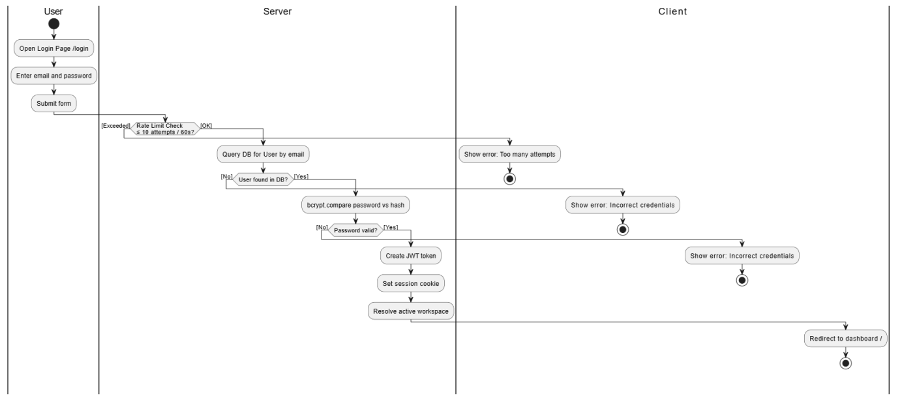
Figure 2.8: User Login Flow

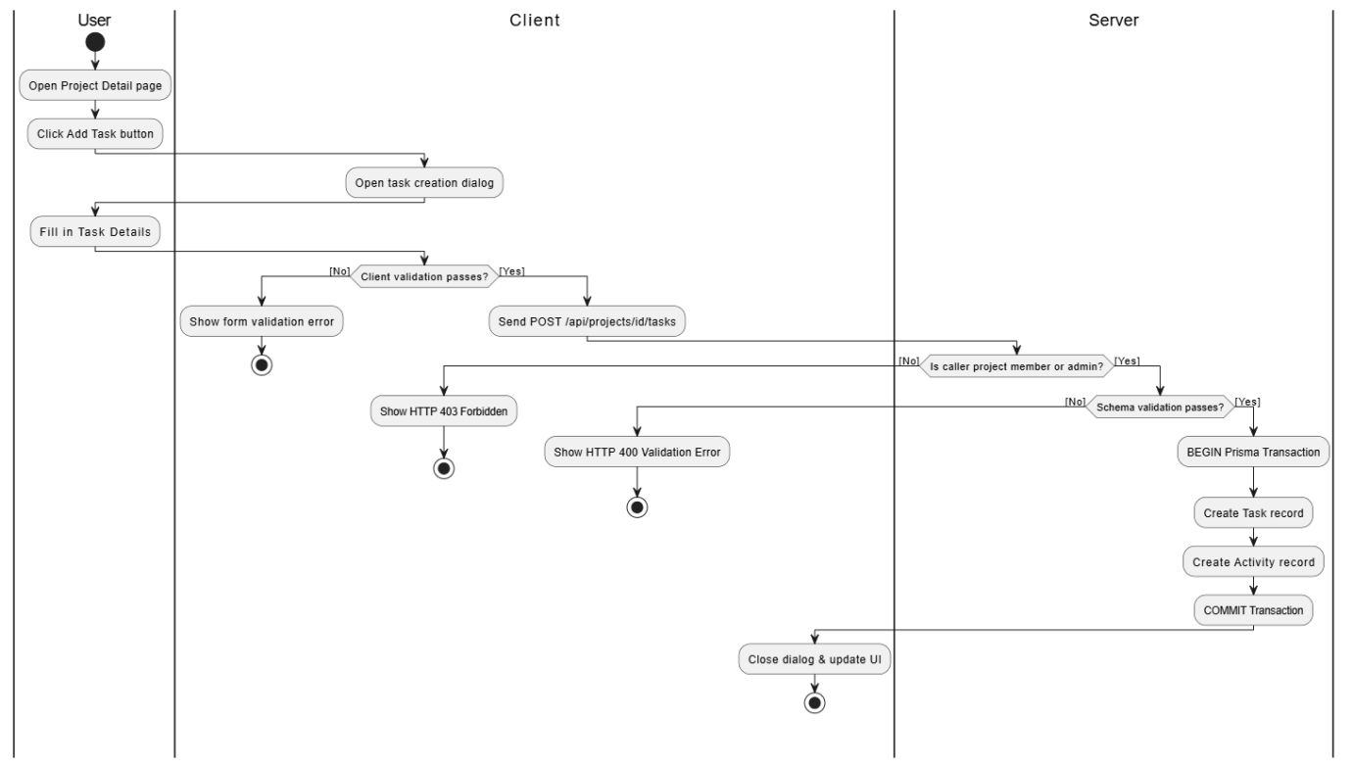
Figure 2.9: Create Task

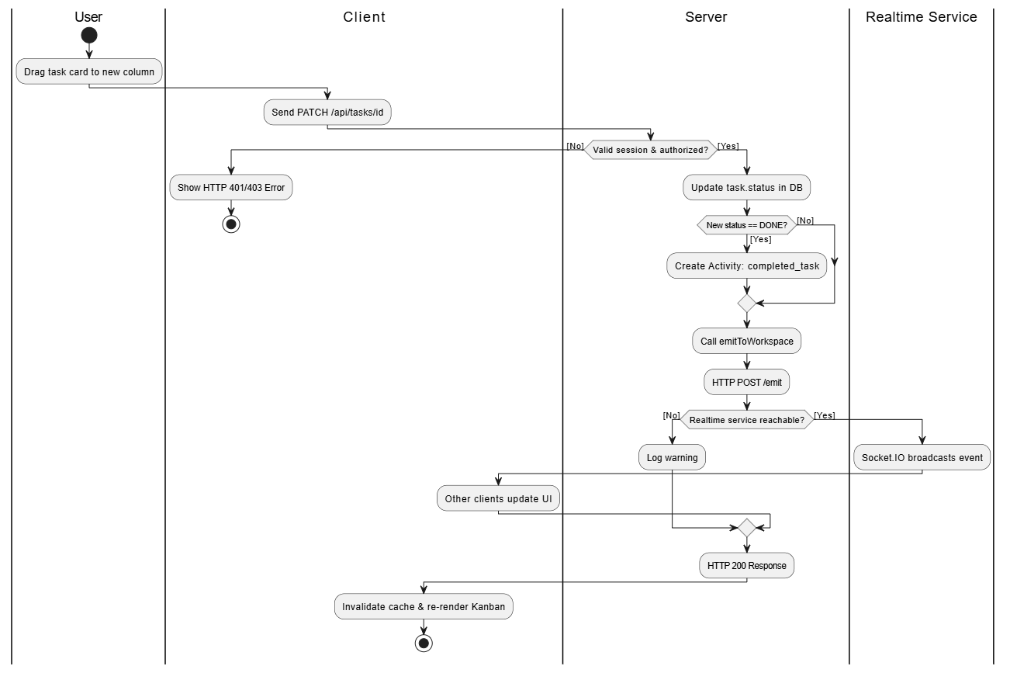
Figure 2.10: Real-time Task Status Update

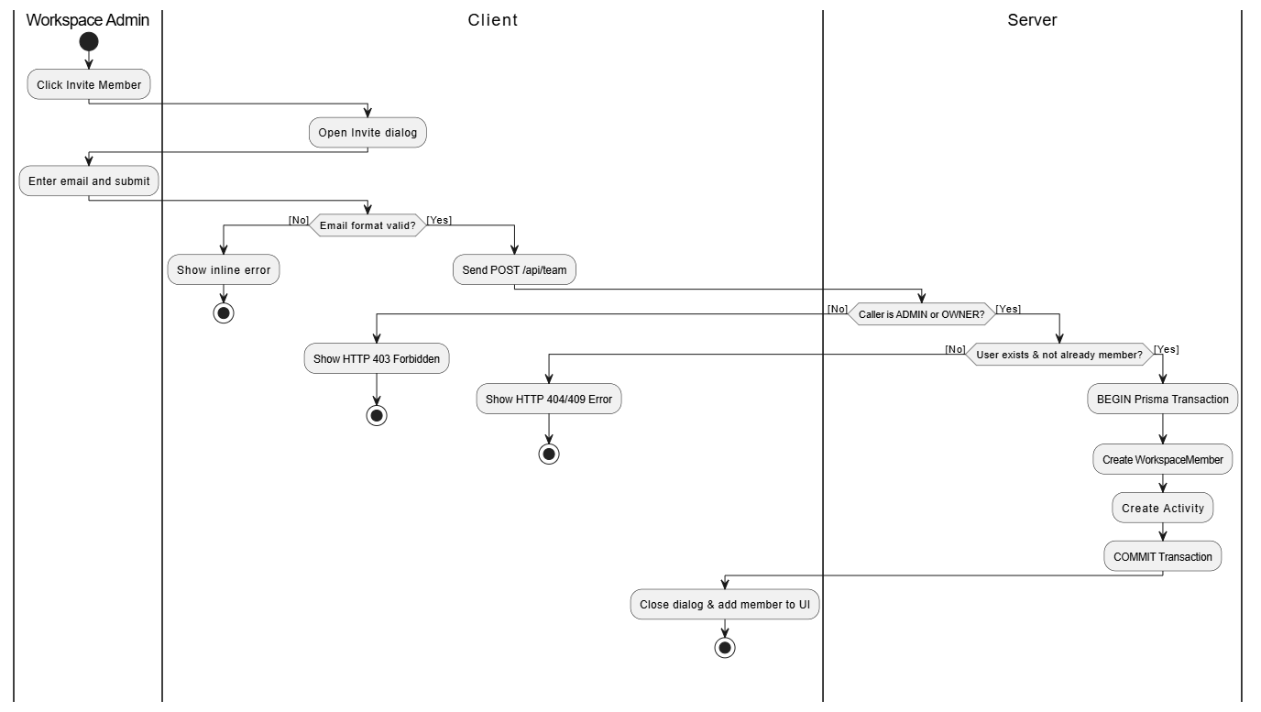
Figure 3.11: Invite Workspace Member

II.6 Entity Relationship Diagram
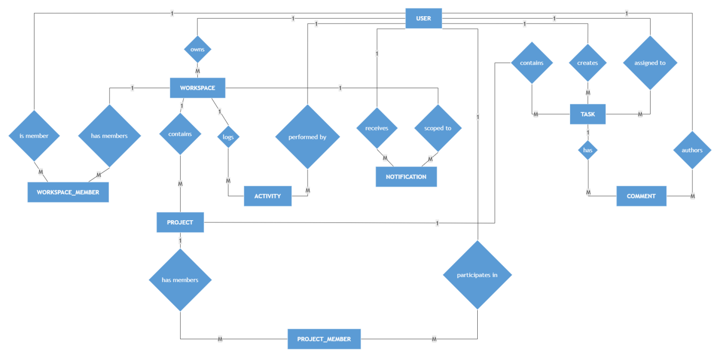
Figure 2.12: Entity Relationship Diagram

III. Analysis and Design models.

III.1 System High-Level Design
- Biểu đồ triển khai
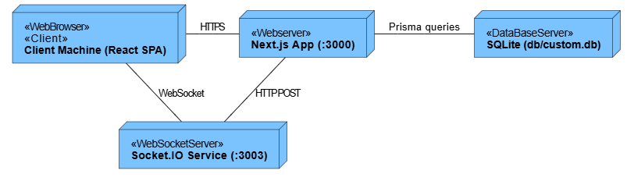
Figure 3.1: Deployment

- Biểu đồ kiến trúc chi tiết
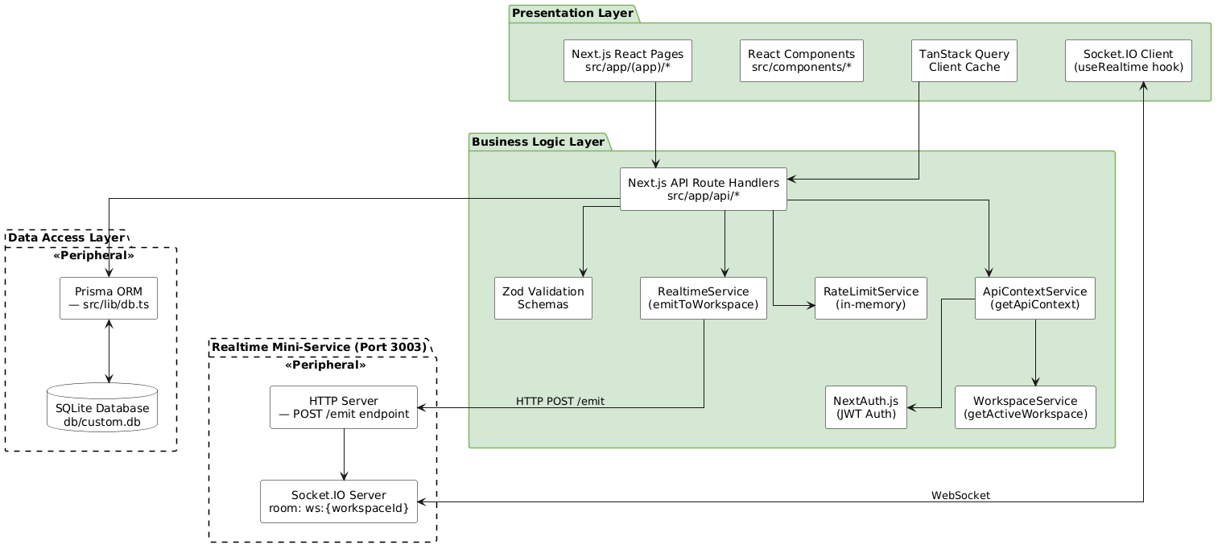
Figure 4: Architecture

III.3 Component and Package Diagram

III.3.1 Component Diagram
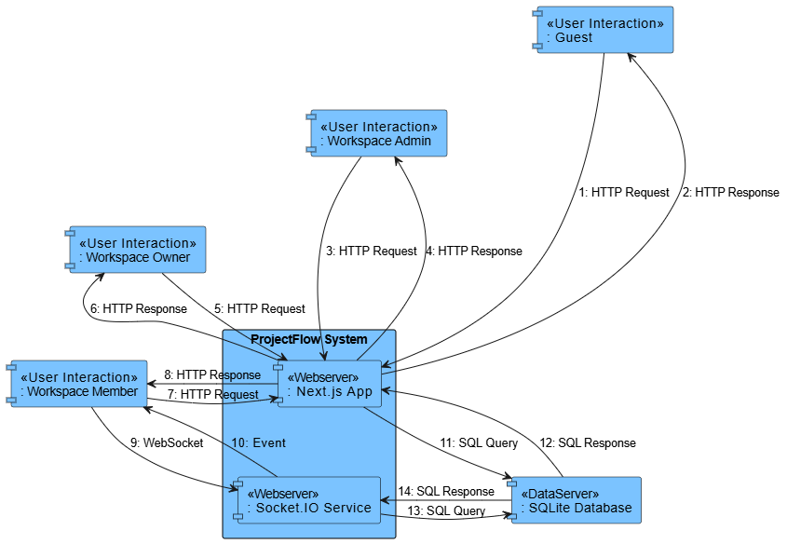
Figure 5.3: Component

III.3.1 . Package Diagram
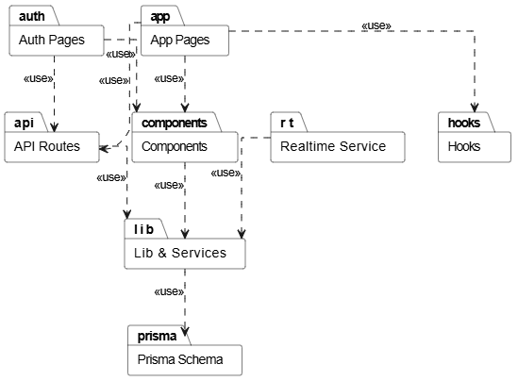
Figure 6.4: Package

Package descriptions
No | Package | Description
01 | app/(app)/ | All authenticated page routes: Dashboard, Projects (list + detail), Team, Calendar, My Tasks, Settings
02 | app/(auth)/ | Authentication pages: Login, Register — accessible without session
03 | app/api/ | Next.js API Route Handlers for all backend REST endpoints
04 | components/app/ | Feature-specific React components grouped by domain (dashboard/, projects/, team/, settings/)
05 | components/ui/ | Shadcn UI primitive components: Button, Card, Dialog, Input, Select, Tabs, Badge, etc.
06 | lib/auth.ts | NextAuth.js configuration with CredentialsProvider, JWT callbacks, and session callbacks
07 | lib/db.ts | Prisma Client singleton — prevents multiple instances during Next.js dev hot-reload
08 | lib/api-context.ts | getApiContext() — resolves authenticated user + active workspace + membership role for every API route
09 | lib/workspace.ts | getActiveWorkspace() — resolves active workspace from workspaceId HTTP cookie
10 | lib/constants.ts | Domain constants: status/priority arrays and enums, human-readable labels, TailwindCSS badge class maps
11 | lib/rate-limit.ts | In-memory sliding-window rate limiter used on the login endpoint
12 | lib/realtime.ts | emitToWorkspace() — server-side helper that POSTs events to the Socket.IO mini-service
13 | hooks/use-realtime.ts | Client-side React hook managing Socket.IO connection and workspace room subscription
14 | prisma/schema.prisma | Prisma data model: all entity definitions, relations, cascade rules, and unique indexes
15 | mini-services/realtime/ | Standalone Node.js Socket.IO server that receives events from the Next.js app and broadcasts to workspace rooms

IV Detailed Design

IV.4.1 Authentication

IV.4.1.1 Class Diagram
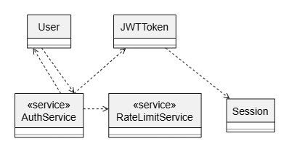
Figure 7.1: Class - Authentication

IV.4.1.2 Sequence Diagram
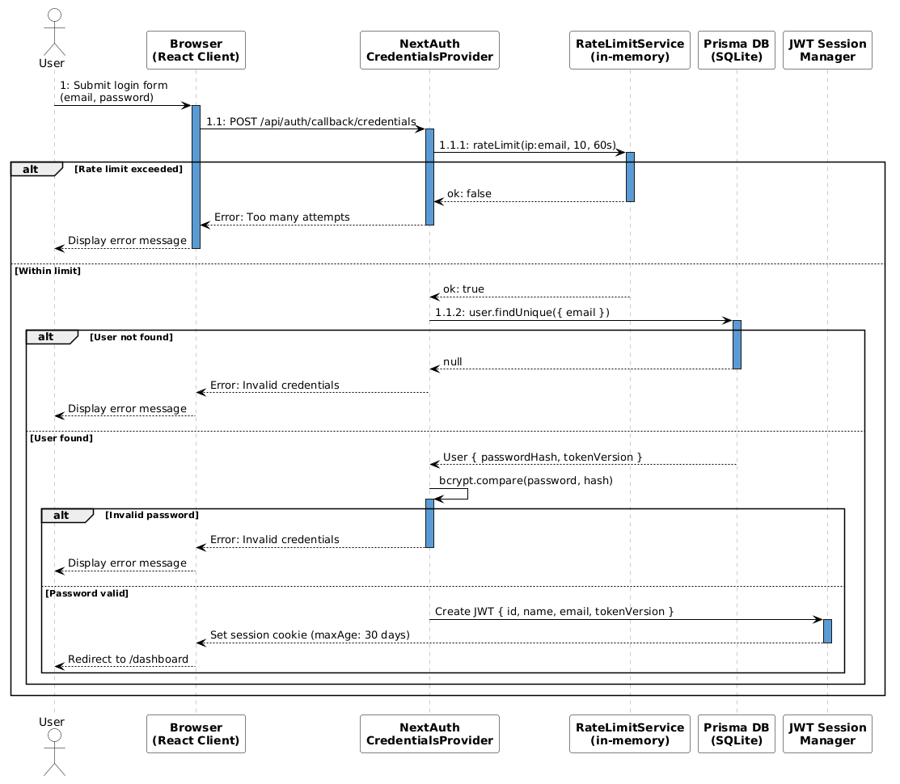
Figure 8.2: Sequence - Login

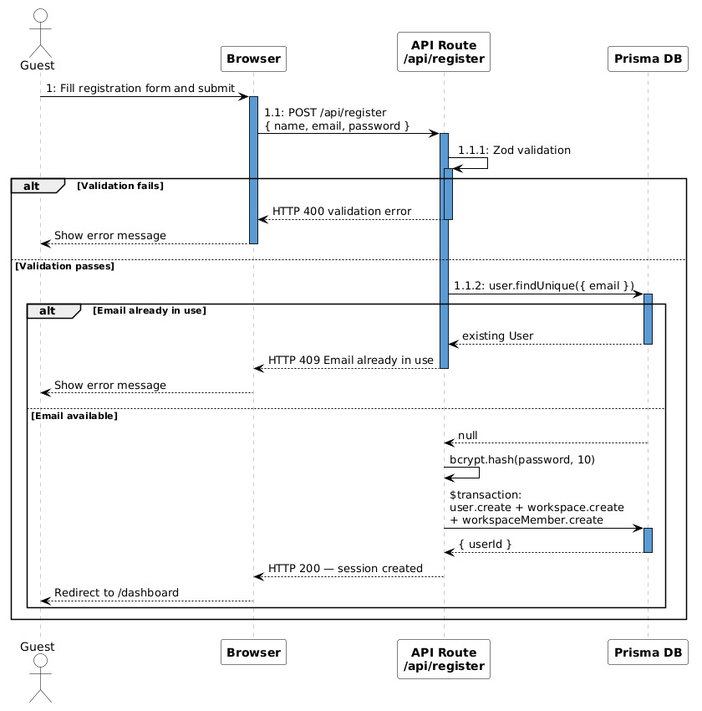
Figure 9.3: Sequence - Register Account

IV.4 .1.3 Communication Diagram
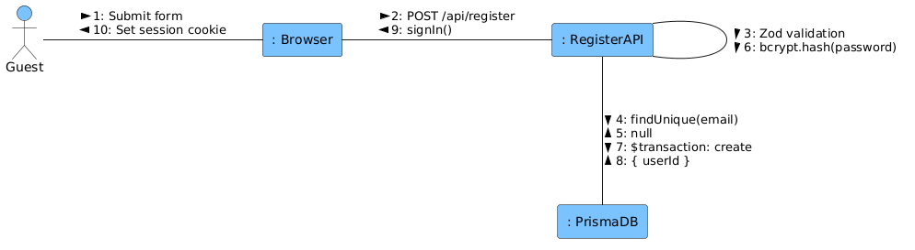
Figure 10.4: Communication - Register Account

IV.4.1.4 State diagram

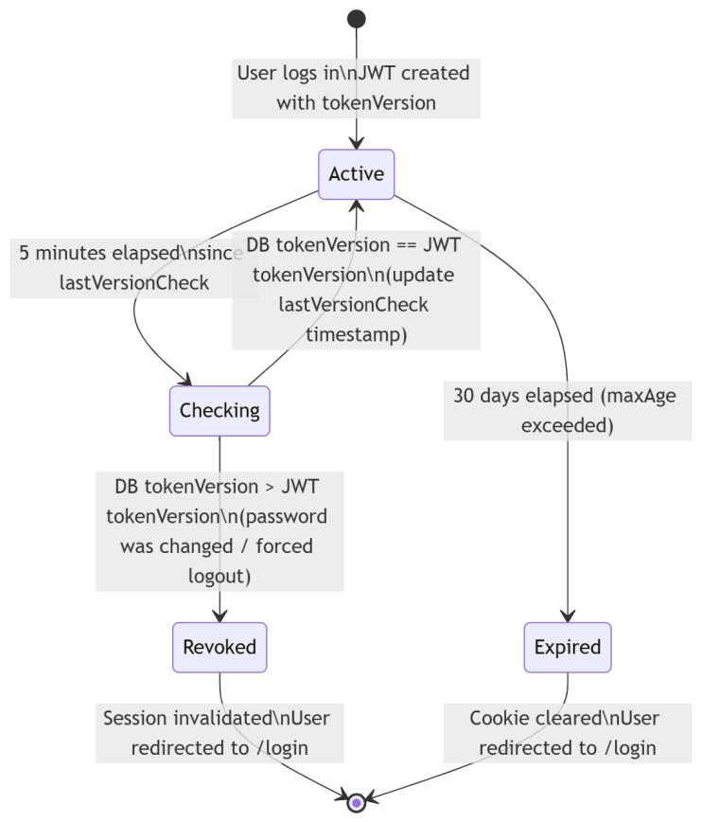
Figure 11: State - Jwt Token Lifecycle

IV.4.2 Workspace & Team Management

IV.4.2.1 Class Diagram
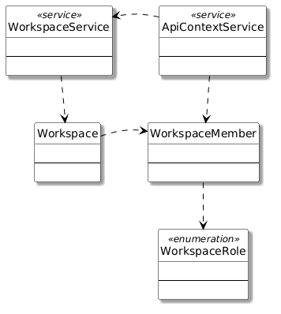
Figure 12.1: Class - Workspace & Team

IV.4.2.2 Sequence Diagram
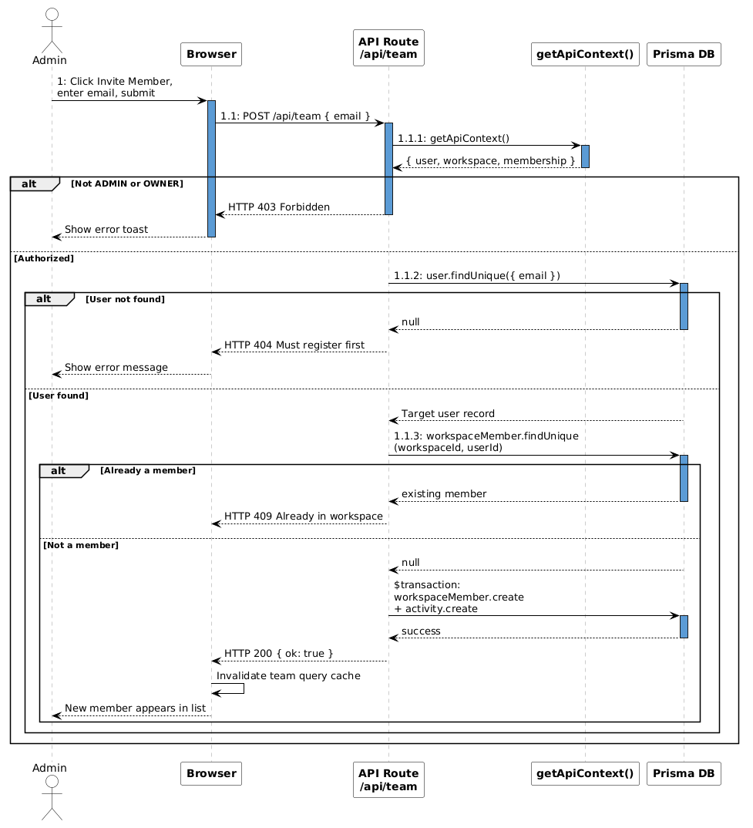
Figure 13.2: Sequence - Invite Member
IV.4 .2.3 Communication Diagram
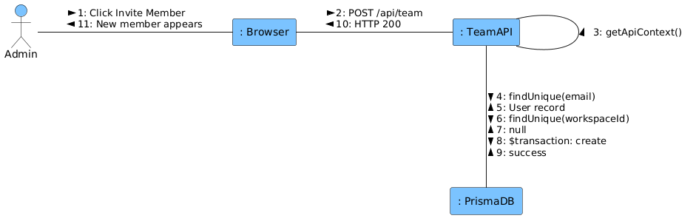
Figure 14.4: Communication - Invite Member

IV.4.2.4 State diagram
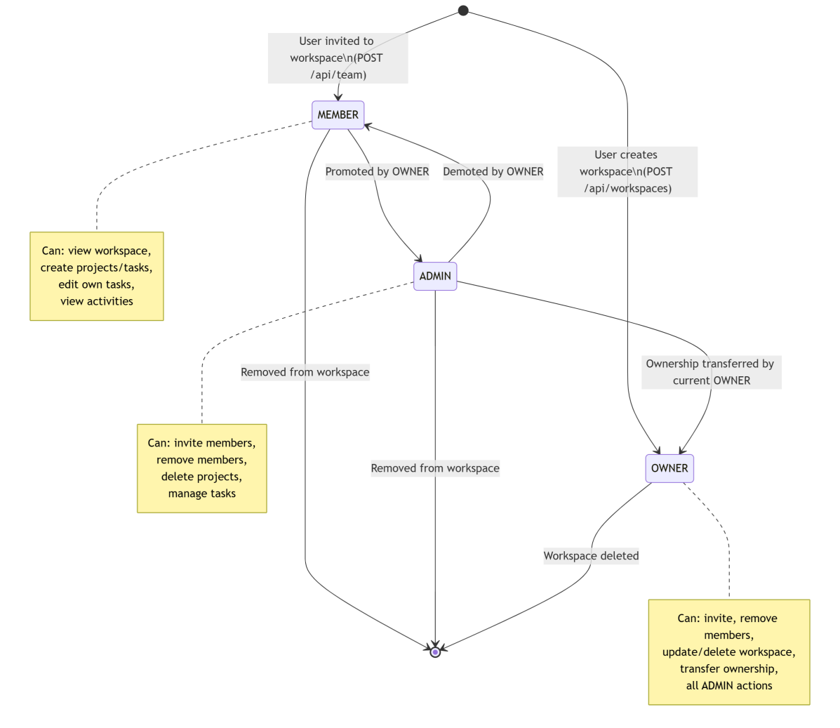
Figure 15: State - Member Role

IV.4.3 Project Management

IV.4.3.1 Class Diagram
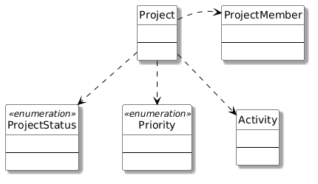
Figure 16.1: Class - Project Management

IV.4.3.2 Sequence Diagram
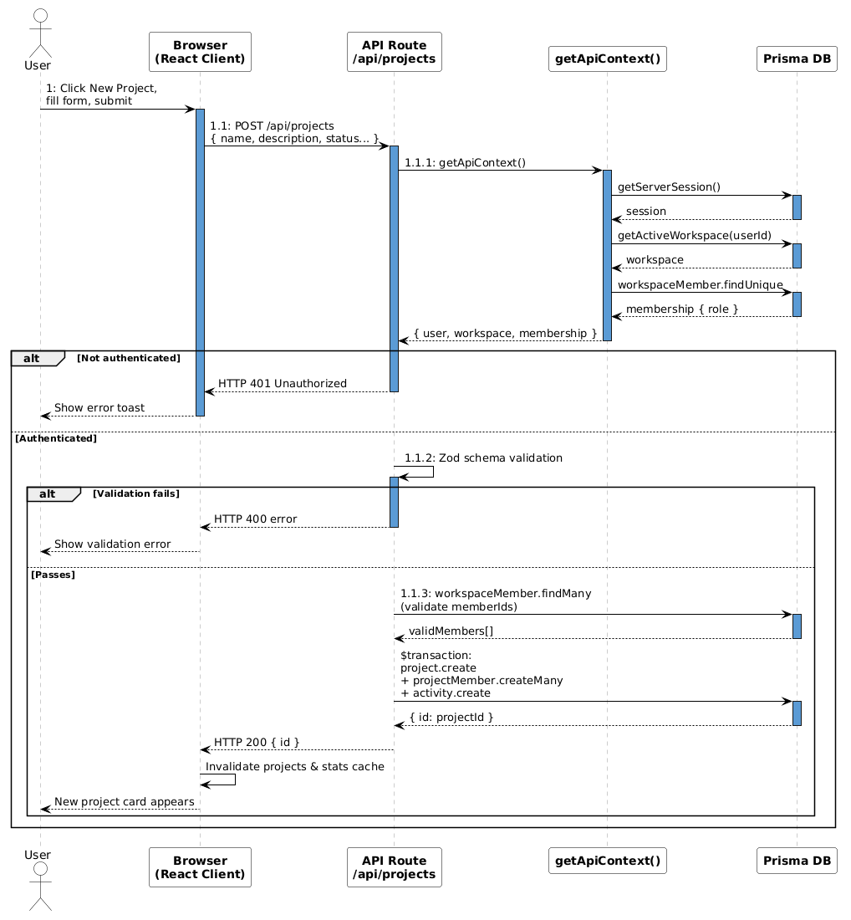
Figure 17.2: Sequence - Create Project
IV.4.3.3 Communication Diagram
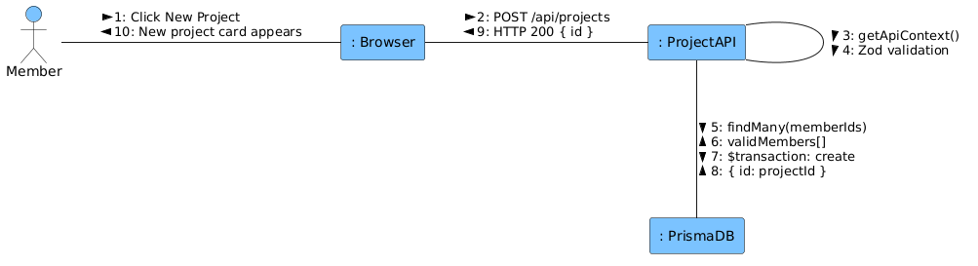
Figure 18.4: Communication - Create Project

IV.4.1.4 State diagram
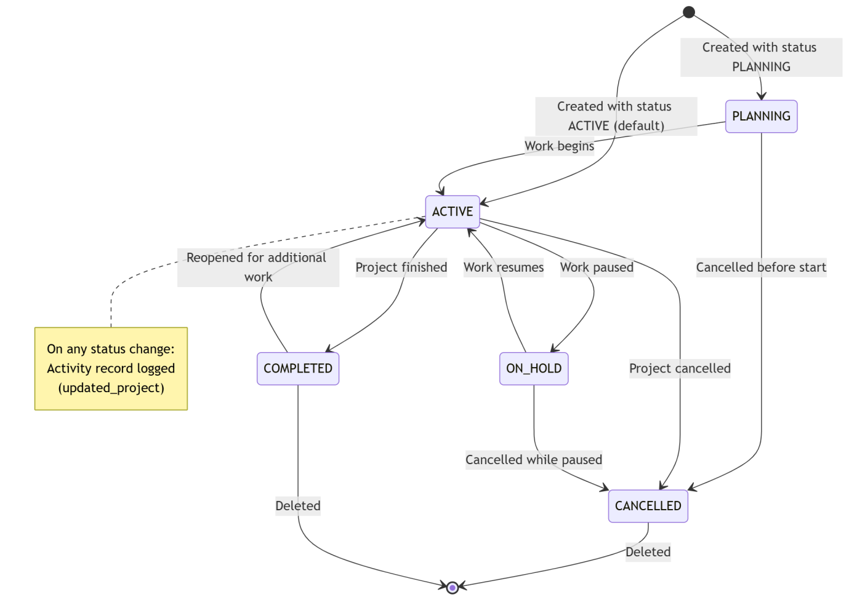
Figure 19: State - Project Lifecycle
IV.4.4 Task Management
IV.4.4.1 Class Diagram
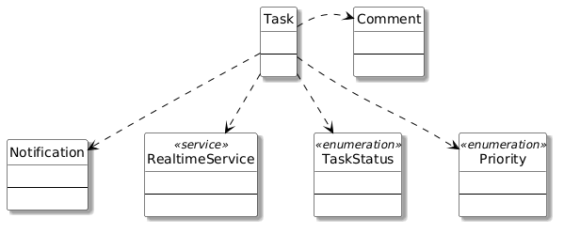
Figure 20: Class - Task Management
IV.4.4.2 Sequence Diagram
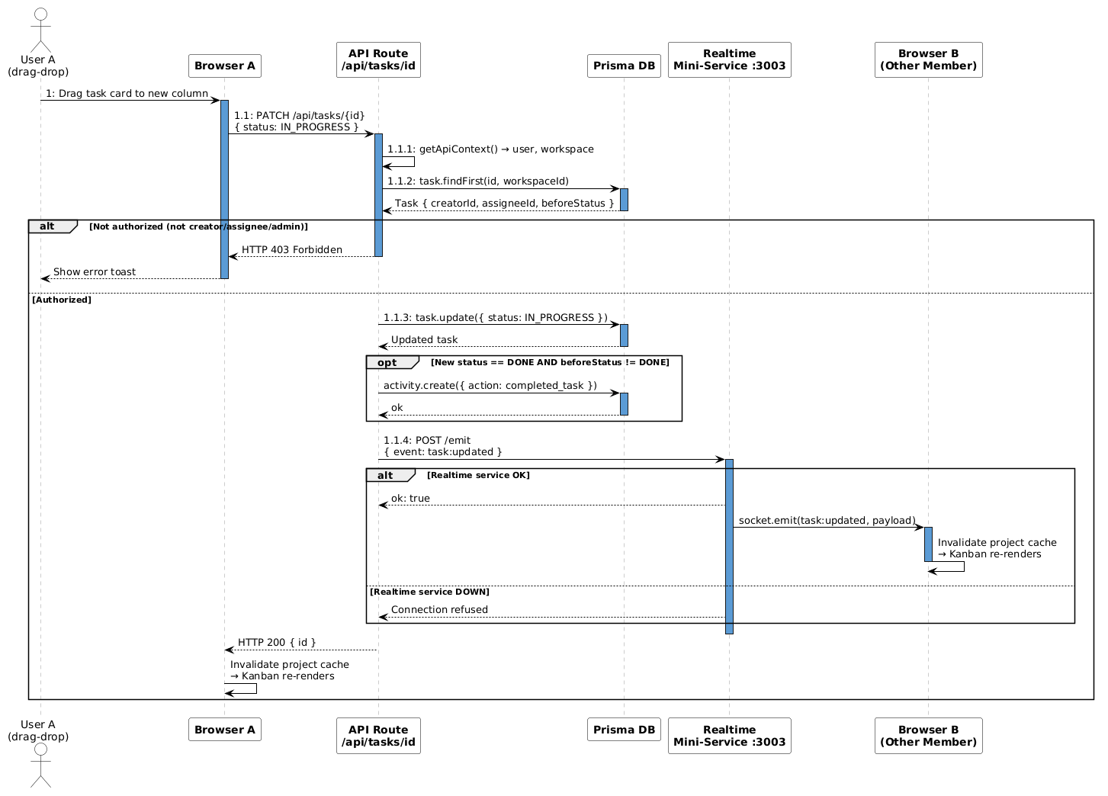
Figure 21: Sequence - Update Task Status
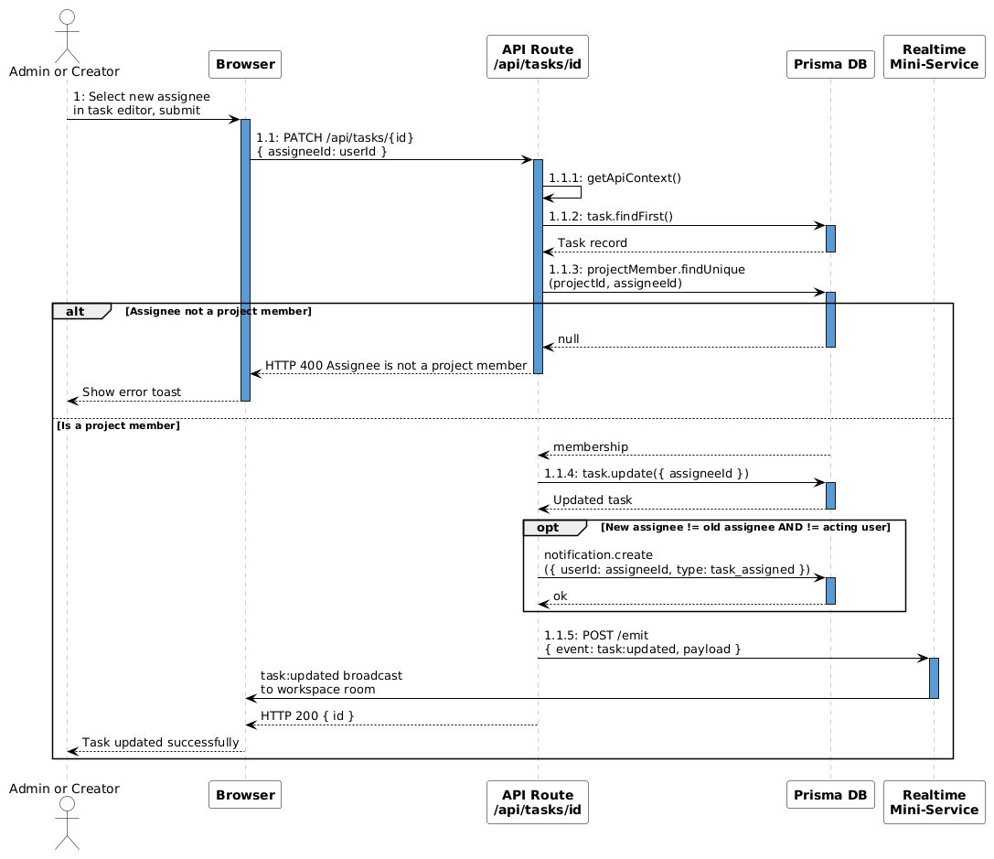
Figure 22: Sequence - Assign Task

IV.4 .4.3 Communication Diagram
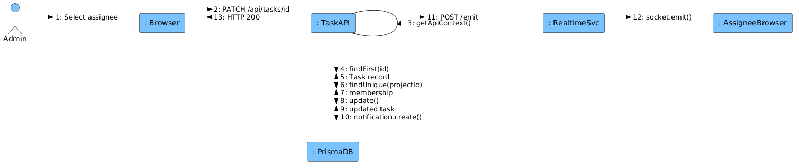
Figure 23: Communication - Assign Task

IV.4.4.4 State diagram

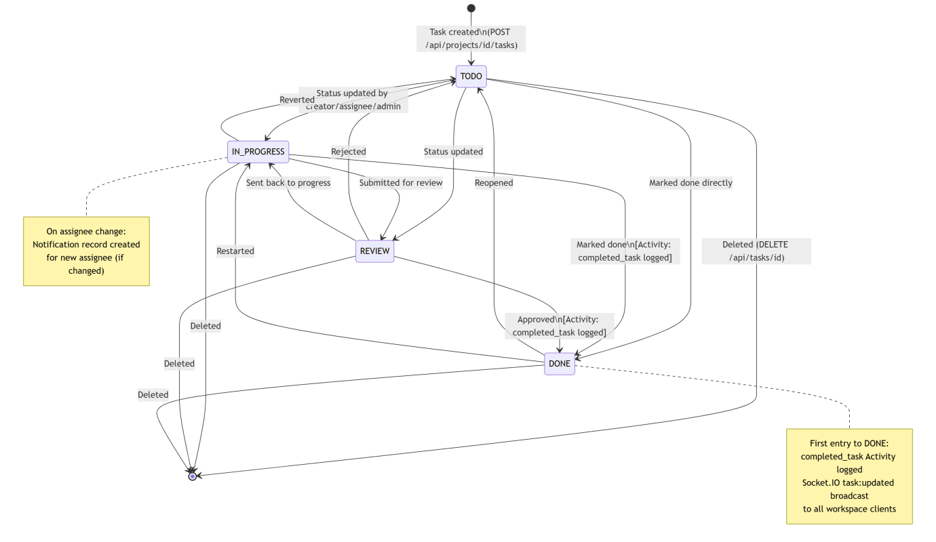
Figure 24. State - Task Lifecycle
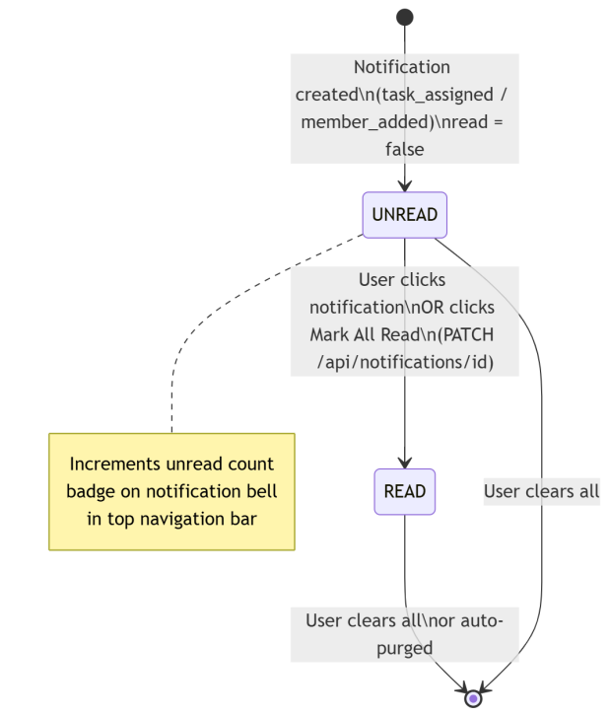
Figure 25. State - Notification Lifecycle

IV.5 Database Design
model User {
id String @id @default(cuid()) // Unique user identifier
name String // Display name
email String @unique // Login email (stored lowercase)
passwordHash String // bcrypt hash of password
image String? // Avatar URL
tokenVersion Int @default(0) // Incremented on password change for session invalidation
createdAt DateTime @default(now())
updatedAt DateTime @updatedAt

workspaces Workspace[]
memberships WorkspaceMember[]
projects ProjectMember[]
tasks Task[] @relation("AssignedTasks")
createdTasks Task[] @relation("CreatedTasks")
comments Comment[]
activities Activity[]
notifications Notification[]
}

model Workspace {
id String @id @default(cuid()) // Unique workspace identifier
name String // Workspace display name
image String? // Workspace avatar URL
ownerId String // Reference to workspace owner
owner User @relation(fields: [ownerId], references: [id], onDelete: Cascade)
createdAt DateTime @default(now())
updatedAt DateTime @updatedAt
members WorkspaceMember[]
projects Project[]
activities Activity[]
notifications Notification[]
}
model WorkspaceMember {
id String @id @default(cuid())
workspaceId String
workspace Workspace @relation(fields: [workspaceId], references: [id], onDelete: Cascade)
userId String
user User @relation(fields: [userId], references: [id], onDelete: Cascade)
role String @default("MEMBER") // OWNER, ADMIN, or MEMBER
joinedAt DateTime @default(now()) // When user joined the workspace
@@unique([workspaceId, userId]) // User can only appear once per workspace
}
model Project {
id String @id @default(cuid())
workspaceId String
workspace Workspace @relation(fields: [workspaceId], references: [id], onDelete: Cascade)
name String // Project name (2–80 characters)
description String? // Project description (≤ 500 characters)
status String @default("ACTIVE") // ACTIVE, PLANNING, COMPLETED, ON_HOLD, CANCELLED
priority String @default("MEDIUM") // LOW, MEDIUM, HIGH, CRITICAL
startDate DateTime? // Project start date
dueDate DateTime? // Project due date (must be ≥ startDate)
createdAt DateTime @default(now())
updatedAt DateTime @updatedAt
members ProjectMember[]
tasks Task[]
}
model ProjectMember {
id String @id @default(cuid())
projectId String
project Project @relation(fields: [projectId], references: [id], onDelete: Cascade)
userId String
user User @relation(fields: [userId], references: [id], onDelete: Cascade)
role String @default("MEMBER") // Role within the project
joinedAt DateTime @default(now()) // When user was added to project
@@unique([projectId, userId]) // User can only appear once per project
}
model Task {
id String @id @default(cuid())
projectId String
project Project @relation(fields: [projectId], references: [id], onDelete: Cascade)
title String // Task title (2–120 characters)
description String? // Task description (≤ 1000 characters)
status String @default("TODO") // TODO, IN_PROGRESS, REVIEW, DONE
priority String @default("MEDIUM") // LOW, MEDIUM, HIGH, CRITICAL
assigneeId String? // Optional assigned user
assignee User? @relation("AssignedTasks", fields: [assigneeId], references: [id], onDelete: SetNull)
creatorId String // User who created the task
creator User @relation("CreatedTasks", fields: [creatorId], references: [id], onDelete: Cascade)
dueDate DateTime? // Task due date
createdAt DateTime @default(now())
updatedAt DateTime @updatedAt
comments Comment[]
}
model Comment {
id String @id @default(cuid())
taskId String
task Task @relation(fields: [taskId], references: [id], onDelete: Cascade)
userId String
user User @relation(fields: [userId], references: [id], onDelete: Cascade)
body String // Comment text content
createdAt DateTime @default(now())
updatedAt DateTime @updatedAt
}
model Activity {
id String @id @default(cuid())
workspaceId String
workspace Workspace @relation(fields: [workspaceId], references: [id], onDelete: Cascade)
userId String?
user User? @relation(fields: [userId], references: [id], onDelete: SetNull)
action String // created_project, updated_task, added_member, etc.
entityType String // WORKSPACE, PROJECT, TASK, MEMBER
entityId String // ID of the affected entity
message String // Human-readable activity description
createdAt DateTime @default(now())
}
model Notification {
id String @id @default(cuid())
userId String
user User @relation(fields: [userId], references: [id], onDelete: Cascade)
workspaceId String
workspace Workspace @relation(fields: [workspaceId], references: [id], onDelete: Cascade)
type String // task_assigned, member_added, task_commented
message String // Human-readable notification message
read Boolean @default(false) // Whether the notification has been read
link String? // Optional in-app navigation link
createdAt DateTime @default(now())
}

V. Implementation

V.1 Map architecture to the structure of the project
- Overview of the Chosen Architecture
ProjectFlow uses a Layered Architecture (3-tier variant) with an additional decoupled real-time service. This architectural style was selected because:
- Maintainability (NFR-14): Clear separation of concerns makes it easy to modify one layer without impacting others. For example, switching the database from SQLite to PostgreSQL requires only a one-line change in prisma/schema.prisma.
- Security (NFR-03): Business logic and authorization rules are enforced server-side in the Business Logic Layer via getApiContext(), preventing client-side bypass of access controls.
- Scalability (NFR-11): The Socket.IO mini-service runs as a separate process and can be horizontally scaled without redeploying the Next.js application.
- Testability (NFR-13): Each layer can be tested independently — unit tests for service utilities (rate limiter, constants), integration tests for API routes.
- Mapping to Project Structure
Architecture Layer | Folder / Files | Responsibilities
Presentation Layer | src/app/(app)/ | Authenticated page components: Dashboard, Projects, Team, Calendar, My Tasks, Settings
Presentation Layer | src/app/(auth)/ | Authentication pages: Login, Register
Presentation Layer | src/components/ | Reusable React components (feature + Shadcn UI primitives)
Presentation Layer | src/hooks/use-realtime.ts | Socket.IO client-side connection management
Business Logic Layer | src/app/api/ | Next.js API Route Handlers — all REST endpoints
Business Logic Layer | src/lib/auth.ts | NextAuth.js configuration (CredentialsProvider, JWT/session callbacks)
Business Logic Layer | src/lib/api-context.ts | getApiContext() — resolves user, workspace, membership role
Business Logic Layer | src/lib/workspace.ts | getActiveWorkspace() — resolves active workspace from cookie
Business Logic Layer | src/lib/rate-limit.ts | In-memory sliding-window rate limiter for login endpoint
Business Logic Layer | src/lib/realtime.ts | emitToWorkspace() — POSTs events to Socket.IO mini-service
Business Logic Layer | src/lib/constants.ts | Domain constants, enums, validation lists, badge CSS class maps
Data Access Layer | src/lib/db.ts | Prisma Client singleton
Data Access Layer | prisma/schema.prisma | Database schema: all entities, relations, indexes, cascade rules
Data Access Layer | db/custom.db | SQLite database file
Realtime Service | mini-services/realtime/index.ts | Standalone Socket.IO server (port 3003) for workspace event broadcasting

V.2 Map Class Diagram and Interaction Diagram to Code
Example 1 — ApiContextService.getApiContext() → src/lib/api-context.ts
// src/lib/api-context.ts
export async function getApiContext() {
const session = await getServerSession(authOptions);
if (!session?.user?.id) {
return { user: null, workspace: null, membership: null };
}
const user = { id: session.user.id, name: session.user.name, email: session.user.email };
const { workspace } = await getActiveWorkspace(user.id);
if (!workspace) return { user, workspace: null, membership: null };

const membership = await db.workspaceMember.findUnique({
where: { workspaceId_userId: { workspaceId: workspace.id, userId: user.id } },
select: { role: true },
});
if (!membership) return { user, workspace: null, membership: null };
return { user, workspace, membership };
}

Example 2 — Task.markDone() → src/app/api/tasks/[id]/route.ts (implements BR-16: completion activity)
// PATCH handler in /api/tasks/[id]/route.ts
const beforeStatus = task.status;
const updated = await db.task.update({ where: { id }, data: { status: d.status } });

// BR-16: First transition to DONE → log completed_task activity
if (d.status === "DONE" && beforeStatus !== "DONE") {
await db.activity.create({
data: {
workspaceId: workspace.id, userId: user.id,
action: "completed_task", entityType: "TASK",
entityId: updated.id,
message: `${user.name} completed task "${updated.title}"`,
},
});
}
// RealtimeService.emitToWorkspace()
await emitToWorkspace(workspace.id, "task:updated", {
id: updated.id, projectId: task.projectId, changes: parsed.data,
});

Example 3 — RateLimitService → src/lib/rate-limit.ts (implements BR-04)
const store = new Map<string, { count: number; resetAt: number }>();

export function rateLimit(key: string, max: number, windowMs: number) {
const now = Date.now();
const entry = store.get(key);
if (!entry || now > entry.resetAt) {
store.set(key, { count: 1, resetAt: now + windowMs });
return { ok: true };
}
entry.count++;
if (entry.count > max) return { ok: false };
return { ok: true };
}

Example 4 — useRealtime hook → src/hooks/use-realtime.ts (client side of Sequence Diagram SD-3)
export function useRealtime(workspaceId?: string) {
const [socket, setSocket] = useState<Socket | null>(null);

useEffect(() => {
if (!workspaceId) return;
const s = io(REALTIME_URL, { path: "/" });
s.on("connect", () => s.emit("join", `ws:${workspaceId}`));
setSocket(s);
return () => {
s.emit("leave", `ws:${workspaceId}`);
s.disconnect();
};
}, [workspaceId]);
return socket;
}

Example 5 — Notification creation → src/app/api/tasks/[id]/route.ts (implements BR-17, BR-18)
// After task.update({ assigneeId })
const newAssigneeId = parsed.data.assigneeId;
if (newAssigneeId && newAssigneeId !== task.assigneeId && newAssigneeId !== user.id) {
await db.notification.create({
data: {
userId: newAssigneeId, workspaceId: workspace.id,
type: "task_assigned",
message: `${user.name} assigned task "${task.title}" to you`,
link: `/projects/${task.projectId}`,
},
});
}

VI. Applying Alternative Architecture Patterns

VI.1 Applying the Service-Oriented Architecture (SOA) architecture
- Problem Identification
The current layered architecture bundles all business logic within a single Next.js application. This creates limitations for the following non-functional requirements:
- NFR-11 (Scalability): All feature domains must scale together — the entire application must be replicated even if only the Task service is under heavy load.
- NFR-10 (Maintainability/Reusability): Business logic (notification dispatch, activity logging) is tightly coupled to HTTP route handlers and cannot be consumed by other clients (mobile app, external integrations, CLI tools).
- As the feature set grows, src/app/api/ becomes a monolithic collection of route handlers.
Note: The mini-services/realtime/ module is already extracted as a standalone service — it serves as a proof of concept and model for the full SOA approach described below.
- SOA-Based Solution
Reorganize system components into independent, loosely-coupled services communicating over well-defined REST APIs:
Current (Monolithic) | SOA Service | Port
/api/auth/* | AuthService | :3001
/api/projects/* | ProjectService | :3002
mini-services/realtime/ | RealtimeService (existing) | :3003
/api/tasks/* | TaskService | :3004
/api/team/* | TeamService | :3005
/api/notifications/* | NotificationService | :3006
/api/stats/* | AnalyticsService | :3007

- Supporting Diagrams
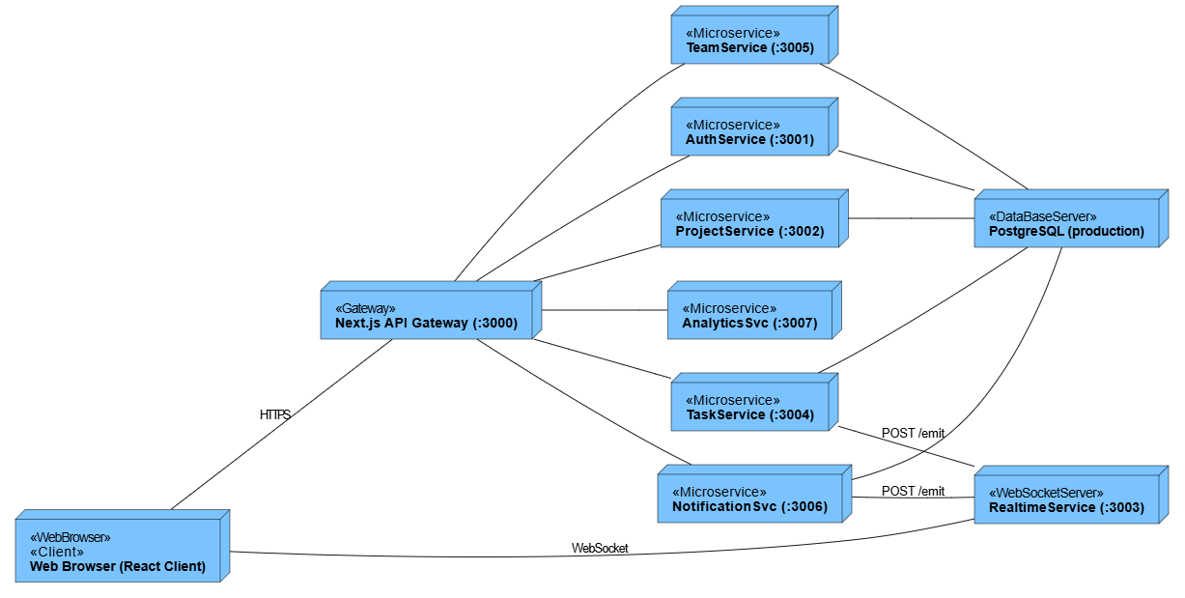
Figure 26.1: SOA Deployment Diagram
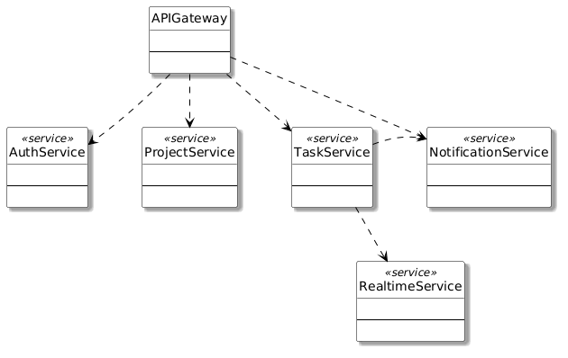
Figure 27. SOA Class Diagram
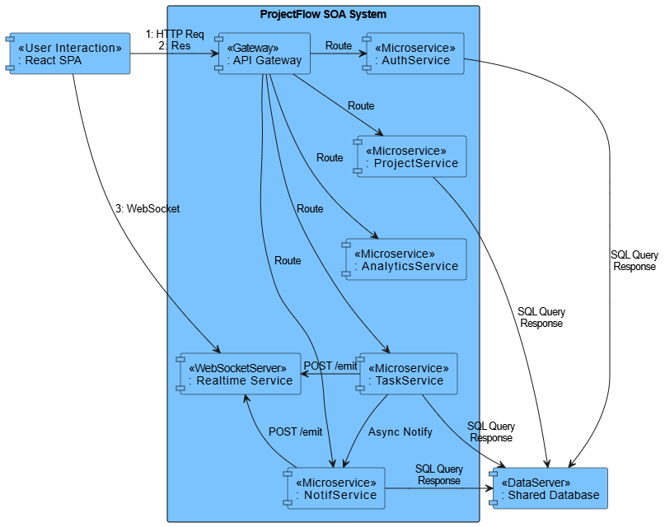
Figure 28.3: SOA Component Diagram

VI.2 Applying Service Discovery Pattern in the service-oriented architecture
- Problem & Requirement
As the system grows to include multiple independent services, hardcoded service URLs become a maintenance and reliability burden:
- NFR-11 (Scalability): When multiple instances of a service are deployed horizontally, the Gateway must dynamically discover which instances are healthy and load-balance across them.
- Static configuration cannot handle dynamic instance registration/deregistration in containerized environments (Kubernetes, Docker Swarm) or cloud auto-scaling groups.
- Without service discovery, a single failing instance causes request failures even if other healthy instances exist.

- Service Discovery-Based Solution
Integrate a Service Registry where services self-register on startup and deregister on shutdown. The API Gateway queries the registry to discover healthy instances, enabling load balancing and automatic failover.
Technology | Description
Consul | Agent-based service mesh with health checking, DNS interface, and key-value store
Netflix Eureka | REST-based service registry with heartbeat-based health checks and self-preservation mode
Kubernetes DNS | Native in-cluster service discovery for containerized deployments — recommended for production

Component | Role
Service Registry | Maintains a live catalog of all registered service instances with health status
Each Service | On startup: registers name, host, port, health endpoint. Sends periodic heartbeats. Deregisters on shutdown.
API Gateway | On each request: queries registry for available instances, applies round-robin or weighted load balancing

- Supporting Diagrams
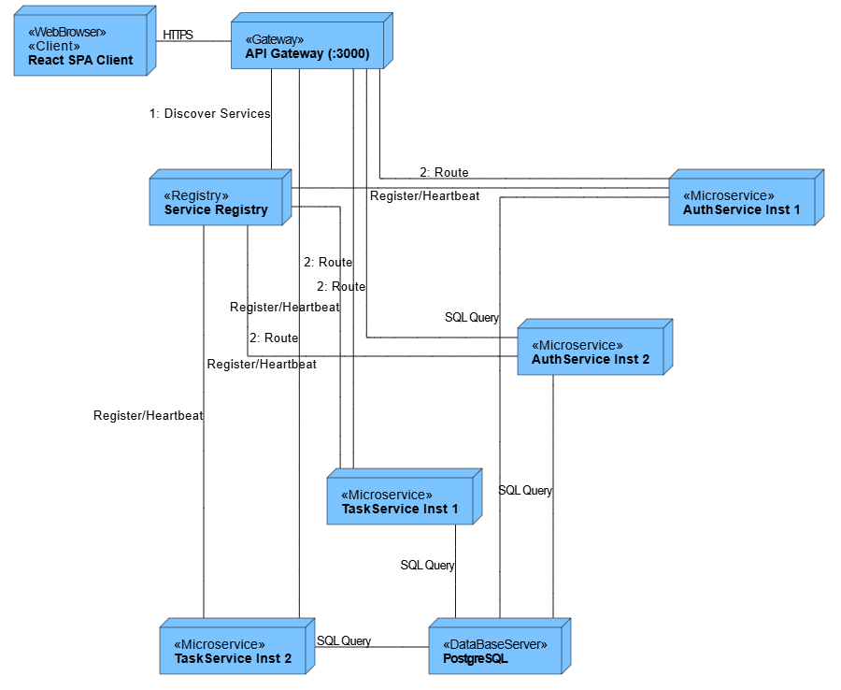
Figure 29.4: Service Discovery Deployment Diagram
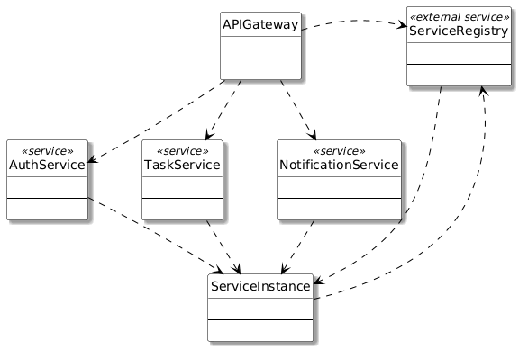
Figure 30. Service Discovery Class Diagram

